Label Water Cycle Diagram | Name_______________________________
Read the definitions below, then label the water cycle diagram.
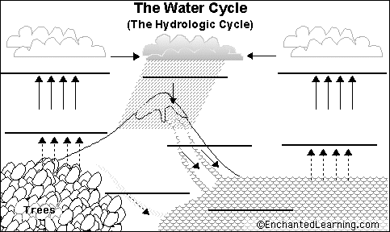

Accumulation - the process in which water pools in large bodies (like oceans, seas and lakes).
Condensation - the process in which water vapor (a gas) in the air turns into liquid water.
Condensing water forms clouds in the sky. Water drops that form on the outside of a glass of icy water are condensed water. (This term appears twice in the diagram.)
Evaporation - the process in which liquid water becomes water vapor (a gas). Water vaporizes from the surfaces of oceans and lakes, from the surface of the land, and from
melts in snow fields.
Precipitation - the process in which water (in the form of rain, snow, sleet, or hail) falls from clouds in the sky.
Subsurface Runoff - rain, snow melt, or other water that flows in underground streams, drains, or sewers.
Surface Runoff - rain, snow melt, or other water that flows in surface streams, rivers, or canals.
Transpiration - the process in which some water within plants evaporates into the atmosphere. Water is first absorbed by the plant's roots, then later exits by evaporating through pores in the plant.

